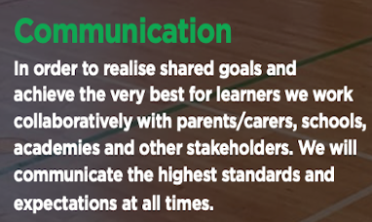


Person Specification for Family Support Worker– Link School
Experience | - At least 2-4 years, experience working in a school environment or other educational setting.  - Experience working with children / young people with additional needs (e.g. special educational needs (SEND) and disabilities, behavioural needs, mental health needs)  - Experience supporting and working with parents of young people.  - Experience working with colleagues and external stakeholders (e.g. from external agencies)  - Experience of keeping good written records  - Commitment to promoting SEND children’s needs demonstrable through previous or current professional or voluntary activities.
Qualifications or Training: | - GCSE C grade or higher (or equivalent) in Maths and English  - Relevant recent evidence of continuous professional development related to SEND.  - Demonstrable levels of Numeracy and literacy equivalent to GCSE  - Willingness to undertake additional training and staff development.  - Tailoring Early Help plans and interventions to individual pupils  - Ability to create good relationships with children, staff, parents and external agencies.  - Knowledge of available support services in the local area  - Safeguarding of children and young people  - Experience or knowledge of Early Help, Parenting courses, multi-agency signposting/MSET.
Practical Skills | - Ability to work with children who have challenging SEND behaviours.  - Strong interpersonal skills and ability to communicate effectively both orally and in writing.  - Knowledge of the principals involved in giving advice and guidance to young people with SEND including the place of confidentiality and sharing information.  - Ability to relate well to vulnerable and challenging learners and their families/carers.  - An understanding of current developments in inclusive education  - Commitment to inclusive practice  - An understanding of the barriers to achievement including social, emotional, and behavioural difficulties and disengagement.  - Capacity to work flexibly and adapt to the changing needs of the school.  - Ability to recognise discrimination in its many forms and to promote equal opportunities policies within the operation of the school.  - Assertive, clear thinking and able to negotiate, challenge, have influence and authority.

