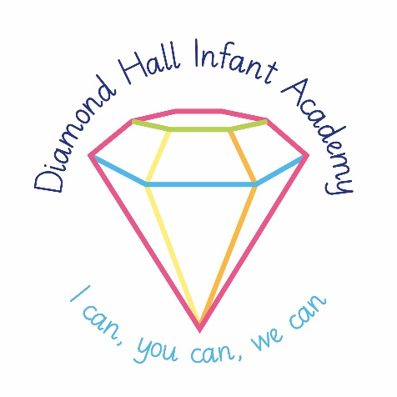

**VACANCY**

**Role:** Administration Assistant

**Location:** Diamond Hall Infant Academy

**Contract Type:** Permanent

**Hours:** 25 hours 11am – 4pm Monday to Friday

**Advert Start Date:** 3rd October 2024

**Required from:** 4th November 2024

**Salary:** SCP 5, £23,500 (pro rata £13,954)

The Trust is seeking to appoint a highly motivated and skilled Administration Assistant to work within Diamond Hall Infant Academy specifically within our main office environment. The successful candidate will provide effective clerical and administrate support for the school. Duties will include maintaining records and office systems including our MIS system, SIMS. You will be completing tasks relating to pupil attendance data, answering the telephone, data input and liaising with parents and third party agencies where necessary.

Applications are invited from committed candidates who are prepared to make a positive contribution to the life and ethos of this inclusive school. The successful candidate must have:

* A recognised level 3 qualification or the equivalent
* Be an effective communicator and able to work in collaboration with colleagues
* Be flexible and resourceful, working calmly and accurately in a busy office environment
* Has excellent organisational, communication and interpersonal skills
* Has good ICT skills and competence using Microsoft Office packages
* Has a good ability to communicate effectively with young children.

Further information about Diamond Hall Infant Academy can be found on our website.

Application packs are available to download from our website [www.diamondhallinfantacademy.co.uk](http://www.diamondhallinfantacademy.co.uk/academy-info/vacancies). Completed application forms should be returned directly to the school by post or by e-mail to our School Business Manager, [Courtney.Snowball@diamondhallinfantacademy.co.uk](mailto:Courtney.Snowball@diamondhallinfantacademy.co.uk), no later than midday on Friday 11th October 2024 and marked for the attention of Mrs L Park, Head Teacher.

**Please note CV applications will not be accepted.**

**Closing date for applications:** 12pm Friday 11th October 2024

**Shortlisting:** Monday 14th October 2024

**Interviews:** 23rd October 2024

***Diamond Hall Infant Academy is committed to safeguarding and promoting the welfare of children and young people and expects all staff and volunteers to be fully committed to our safeguarding policies and procedures, in accordance with Sunderland Local Safeguarding Board Procedures.***

***Pre-employment checks and references will be sought and the successful candidate will need to undertake an enhanced DBS check.***