

September 2023

Dear Applicant

**Science / Design Technology Technician – Full Time, Permanent post**

Thank you for your interest in this key position which is to commence ASAP.

Marden High School is highly successful, with examination results well in excess of national standards.

If after reading the attached material you would like to apply for the post please complete the application form and submit it, together with a letter of application, outlining how well you meet the person specification and the qualities you will bring to this position. Your letter should be no longer than 2 sides of A4.   Applications can be emailed to e.scott@mardenhigh.net

If you would like an informal chat about this opportunity, do not hesitate to contact me.

The closing date for applications is 9am on Wednesday 18 October 2023. Interviews will take place on Wednesday 25 October 2023.

Yours faithfully

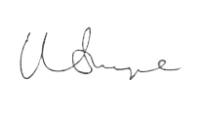

Mr Matt Snape  
**Headteacher**