The Director of Bishop Hogarth Catholic Education Trust and Governors of The English Martyrs Catholic School and Sixth Form College are seeking to appoint a PA to the Headteacher.

Contribute to the delivery of our excellent school operations, through effective PA support to both the Headteacher and Senior Leadership team. Acting as a first point of contact you will ensure the Headteacher’s time is utilised to best effect.

**THE ENGLISH MARTYRS CATHOLIC SCHOOL AND SIXTH FORM COLLEGE**

PA to the Headteacher

**Band 8**

**(scp 12-15)**

**£21,705 - £23,450**

**Actual Salary**

37hpw, Term time plus 10 days

To commence as soon as possible

**Closing Date: Monday 28th Aug 2023 at 9am**

**Interview: Friday 1st Sept 2023**

Delivering a high-quality service, you will be confident and robust in ensuring the Headteachers time is directed to the most appropriate demand and to maximum benefit for our school. This role will assist with the running and organisation of the school. The school is looking for candidates who are:

* Confident and professional

. Organised and self-reliant – able to manage and prioritise your own workload with an ability to organise complex material and appointments.

* Progress chaser and problem solver – acting on enquiries, meeting outcomes and decisions made;
* ICT literate, able to manipulate data, gather and analyse information and communicate effectively;
* Courteous and sensitive – in dealing with often confidential issues; delivering a high level of customer service to all within and external to the school.
* Strong communicator with an interest or background in Education;
* Well organised and can work effectively with a range of stakeholders;
* Flexible, adaptable, with a positive approach to working in a structured environment.

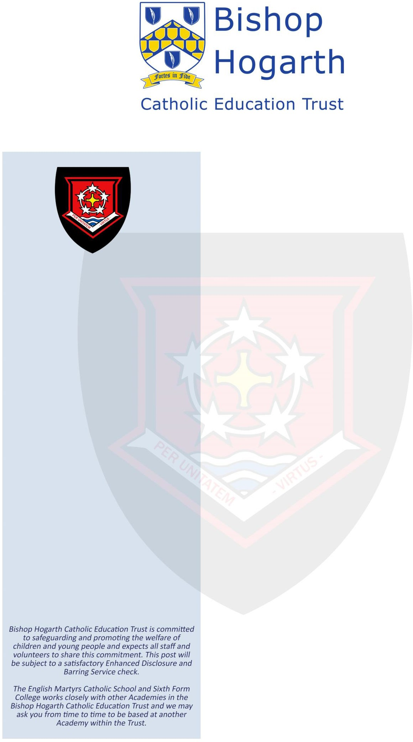

Our School is a vibrant, forward thinking and Christ-centred place to work.

The hours of work are Monday to Friday, 8:00am to 4:30pm with a one-hour lunch break.

**Visits to the school are welcomed. For further information about the post please contact Nicola Denham 01429 273790.Application forms are available at** <https://bhcet.org.uk/vacancies> **and can be returned to the school address by post or to** [**recruitment@ems.bhcet.org.uk**](mailto:recruitment@ems.bhcet.org.uk)