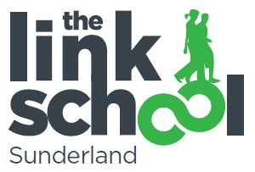

Person Specification for One to One– Link School
Experience | - Experience of delivering a subject(s) including planning, preparation and assessment to raise achievement.  - Experience of engaging extremely disaffected and vulnerable young people.  - Experience of working with students with behavioural, emotional and social difficulties  - Experience of working in partnership with parents  - Knowledge and/or experience of working in partnership with outside agencies  - Ability to demonstrate knowledge and experience of a range of additional educational needs  - Proven commitment to raising the attainment and self esteem of vulnerable students
Qualifications or Training: | - Demonstrable levels of Numeracy and literacy equivalent to GCSE (A-C)  - Hold NVQ Level 2 or other equivalent recognised qualification  - Willingness to undertake additional training and staff development
Practical Skills | - Ability to use ICT effectively to support learning  - Knowledge and understanding of literacy and numeracy strategies  - Understanding the importance of lesson plans. IEPs and learning objectives  - Ability to work with children who have challenging behaviours  - Good organisational skills  - Ability to organise the classroom activities eg set out resources and implement strategies for teaching and learning  - Strong interpersonal skills and ability to communicate effectively both orally and in writing  - Ability to relate well to children and adults  - Ability to work constructively as a team, understanding classroom roles and responsibility and your own position within these  - Philosophy focused on achieving high quality learning and teaching opportunities for every student  - An understanding of current developments in inclusive education  - Commitment to inclusive practice  - An understanding of the barriers to achievement including social, emotional and behavioural difficulties and disengagement.  - Have high expectations of self, pupils and staff and a commitment to raising standards of achievement and attainment  - Ability to deal with highly sensitive information in a confidential manner  - Demonstrable commitment to inclusive education  - Capacity to work flexibly and adapt to the changing needs of the Link School  - Ability to form and maintain appropriate relationships and boundaries with learners

