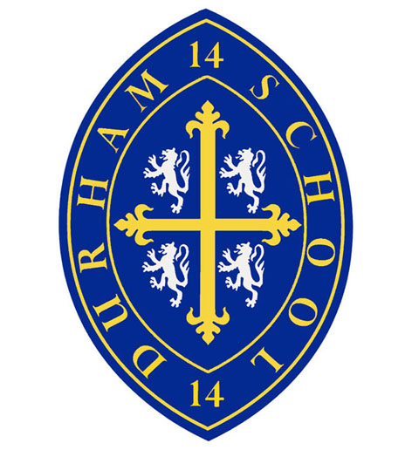

Learning Support Assistant
September 2016

Durham School seeks to appoint suitably qualified Learning Support Assistants for September 2016. The posts are full-time or part-time to provide support to specific pupils within School. Experience of working in a school environment would be an advantage.

Full details of the post and the application process can be found on our website: www.durhamschool.co.uk or by contacting Mrs Susan Spence, Headmaster’s PA on 0191 386 4783. The deadline for applications is 12 Noon on Wednesday 24th August 2016.

Durham School is committed to promoting the safeguarding of children and expects all employees to share this commitment. Any job offer will be made subject to satisfactory checks, including an enhanced DBS disclosure. Durham School is an equal opportunities employer and welcomes applications regardless of age, gender, race, religion, disability or sexual orientation.

Durham School Tel: 0191 386 4783 e-mail: enquiries@durhamschool.co.uk
A Company Limited by Guarantee Registered in England No. 2776914
Registered Charity No. 1023407

